**GROUP 3**

**LIBRARY MANAGEMENT SYSTEM**

**Table of contents:**

1. Tables

**Master Book Table**

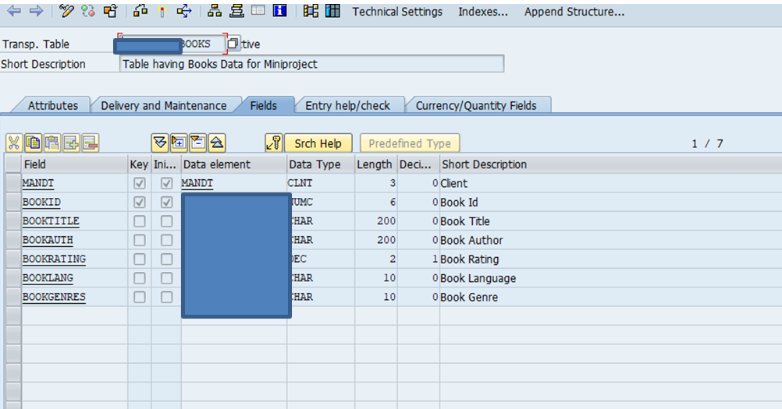

**Payment Table**

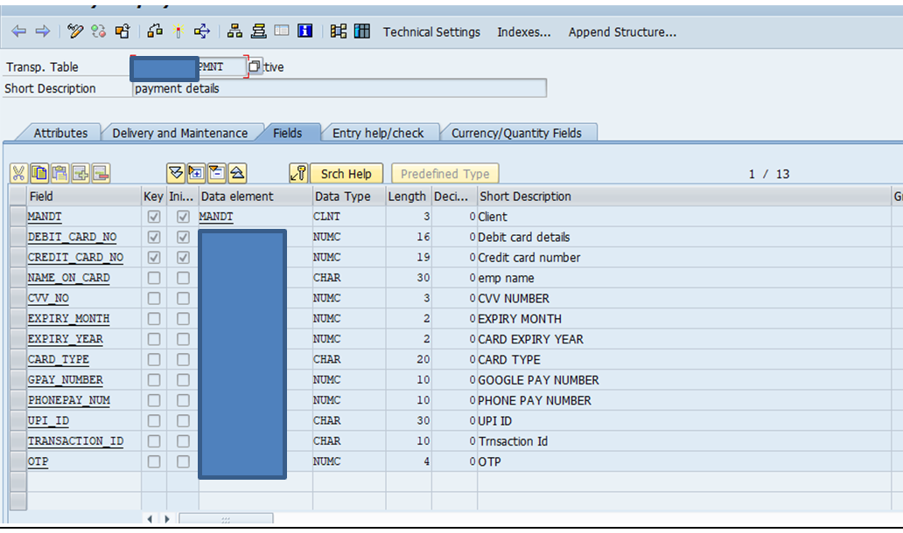

**User Details Table**

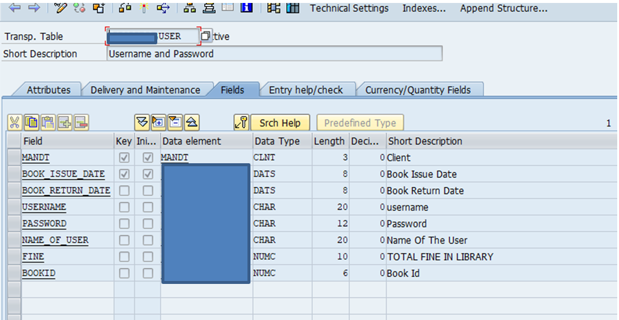

**2.Assumptions:**

*Admins have maintained a user login table which contains all the details of fine, book received, book return date, username and password.

*Validation of card number, otp, username, password everything is done using payment table data assuming it to be a server which will authenticate wether user have entered correct details or not.

*This project is totally based on user perspective. User have no permission to edit data.

**3.Walkthrough**

*User Login Screen: This screen is where user will enter credentials i.e username and password which is validated from user details table.

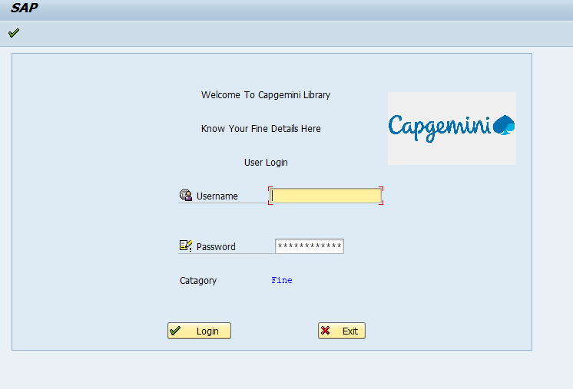

*Welcome Screen: Here the user will see how much fine is imposed on him and is given some functionality which he/she can use.

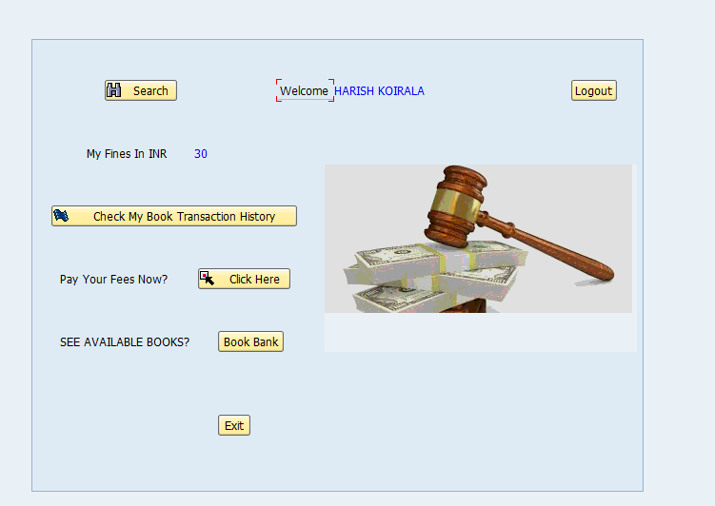

a)Check Transaction History: User can see his history which is shown is ooalv format.

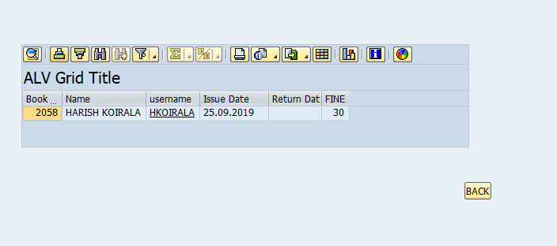

b)Payment: Payment Screen gives user the function of paying using 3 method debit card, credit card, and upi. Details are verified using payment table.

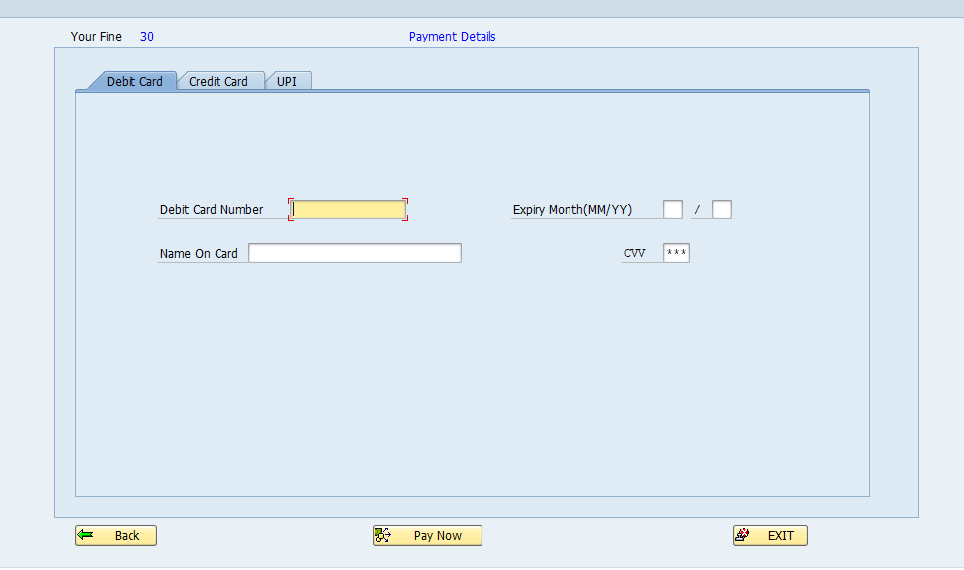

c)Serach Book Using Filter: Search book using filter such as genres of thw book or which language book you want while returning the book.

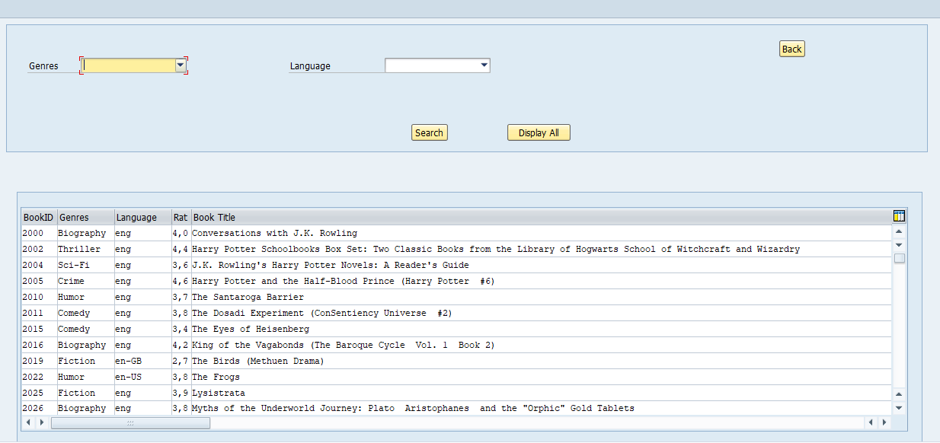

d)See Book Bank: It shows all the books available in the library in alv format.

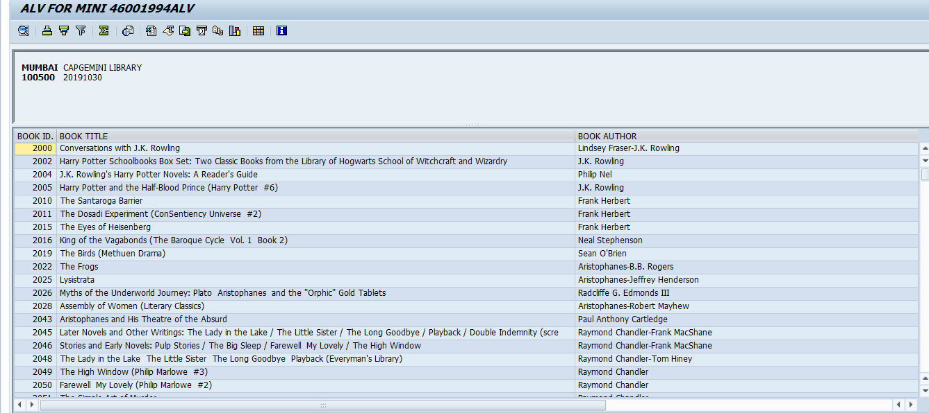

*AFTER SUCCESSFUL PAYMENT withOTP OR UPI: Message WILL be displayed saying as shown is figure below and when tick button is clicked an Adobe form is generated giving complete details of payment.

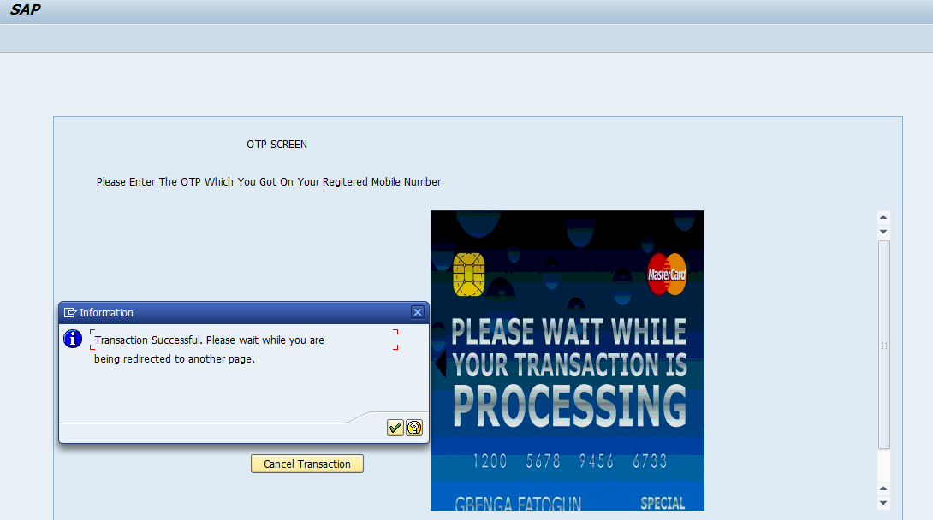

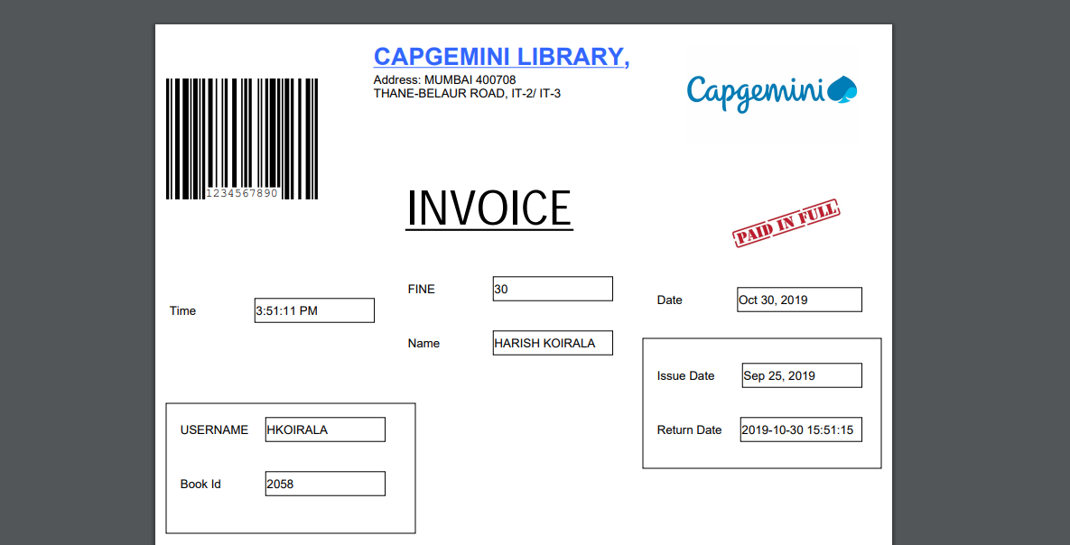

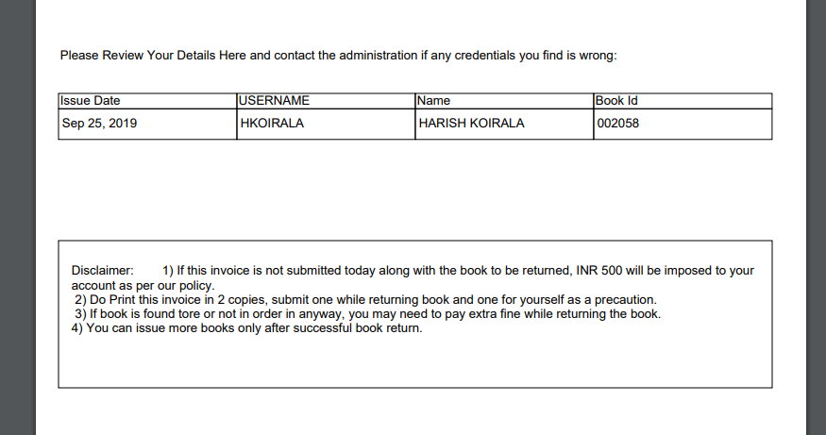

*When the user then checks his transaction history again fine is now 0 and return date is today’s date.

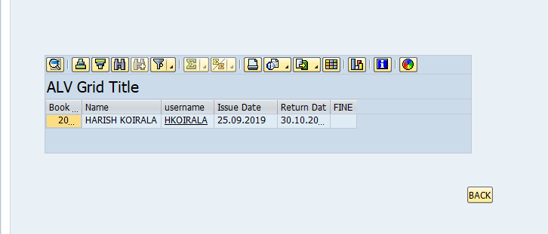

**4.Conclusion:**

1)User login is created for payment of fine.

2)After User Login Functionality has been given to the user which one can use after successful login.

3) Payment now made easier in library.

4)Searching now made easier in library.

5) Keeping track of transaction details now made easier in library.

6) Online receipt generation, skip long lines in library to pay fines, hence book return is now more easier.